DK108
Smart Lighting Controller
Product Specification

Item： DK108
Version：v1.1
date：2018-01-22

All rights reserved.
The content can’t be modified without permission in this document

Historical Releases

Version | Modified Content | Writer | Auditing | date | Department
V1.0 | the first version | Jasmine | Ning Qing | 2017-11-08 | Product dept.
V1.0 | Parameter update | Jasmine | Ning Qing | 2018-01-22 | Product dept.

Development Background

1.1 T2C Instruction
With the rising popularity of smart technology, there are more and more obvious demands for smart lighting. Based on user requirement, Ogemray develop T2C lighting control technology, users can set favorite scenes in APP, then double click normal switch to change brightness/color temperatures/scenes.

1.2 Development Background
Nowadays, intelligence and convenience have turned to be a trend, more and more smart lighting devices need APP to control brightness/color temperature/effect. How to free users from mobile phone, how to quick switch lighting scenes are both considerations for users to choose smart lighting devices. Therefore they have always been the task that technique personnel all over the world have devoted to study.
Now market mainstream physical button functions for smart lighting devices are sole, they have following disadvantages:
1. Turn on or off only by physical button, it is limited by distance and space.
2. Change several fixed color temperatures by physical button, the color temperatures are preset in lamps before products leave factory, users can not choose color temperature and self-customize lighting effects.
3. Control lighting brightness or color temperature by APP, but only adjust via APP, users can not relief themselves from mobile phones.

Product Introduction

2.1 Overview
DK108 is a lighting controller with WiFi and have lighting control function, the lighting controller has 2 ways PWM drive circuit to control color temperature (WW/CW), moreover, it reserve 2 GPIO interfaces to meet scalability requirement. Designed based on cloud platform, The DK108 firmware has advantages such as multipurpose integrating, high stability and strong expandability etc. It has abundant API interface, can be controlled via Android and iOS mobile APP. Through APP, user can deposes of operations such as local control, remote control, timer control, scene control.
DK108 can be applied for commonly used normal 220V switch, integrated with WiFi lighting controller, driver and switch monitoring part. It is a low power, small size, quick connection lighting controller which is suitable for LED lighting control. Nowadays, the constant deepening of economic globalization and increasingly fierce of market competition, gradually lead to homogenization of LED lamps, the lighting controller adopt Ogemray original T2C lighting control technology and leading WiFi technology, make lamp manufacturer optimize products, expand product catalogue and improve market competition thereby to add up users and boost sales.

2.2 Features
- T2C lighting control technology supported, control brightness and color temperature by lighting switch.
- Support the overwhelming majority of SPST.
- Works with Amazon Alexa and the Google assistant, adjust the lamp color temperature and brightness via voice.
- Focus on 81~108W lamps such as ceiling lamp, down lamp or other
- Constant current and isolated power solution, great security performance
- Support 2 ways PWM, applied to control 2 colors LED(CW/WW), meet requirement for color temperature lights and general lights.
- Provide mobile phone APP, support iOS and Android system
- Configure network via mobile APP, smart connection
- Support local and remote control
- Switch ON or OFF by mobile phone APP
- Set timer to turn on/off and event reminder by mobile phone APP
- Control color temperature/brightness by mobile phone APP
- Support flashing dynamic effect, support gradual lighting effect.
- Support FOTA (firmware remote update)
- Support STA/AP/STA+AP work mode
- Monitor lighting controller work state by watchdog, if the lighting controller runs across abnormal states, the lighting controller will auto power off and restart.
- Support manual reset function.

2.3 Product Appearance
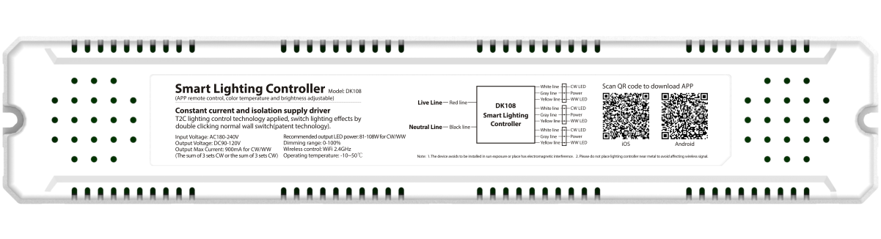 Figure2-1 DK108 front view

2.4 Works with Alexa and the Google assistant 、
The smart lighting controller works directly with Amazon Alexa and the Google assistant, you can manage your devices through voice control like turn on/off, change color/color temperature. Assign a name to each smart lighting controller and communicate with each bulb by name when making a voice command.
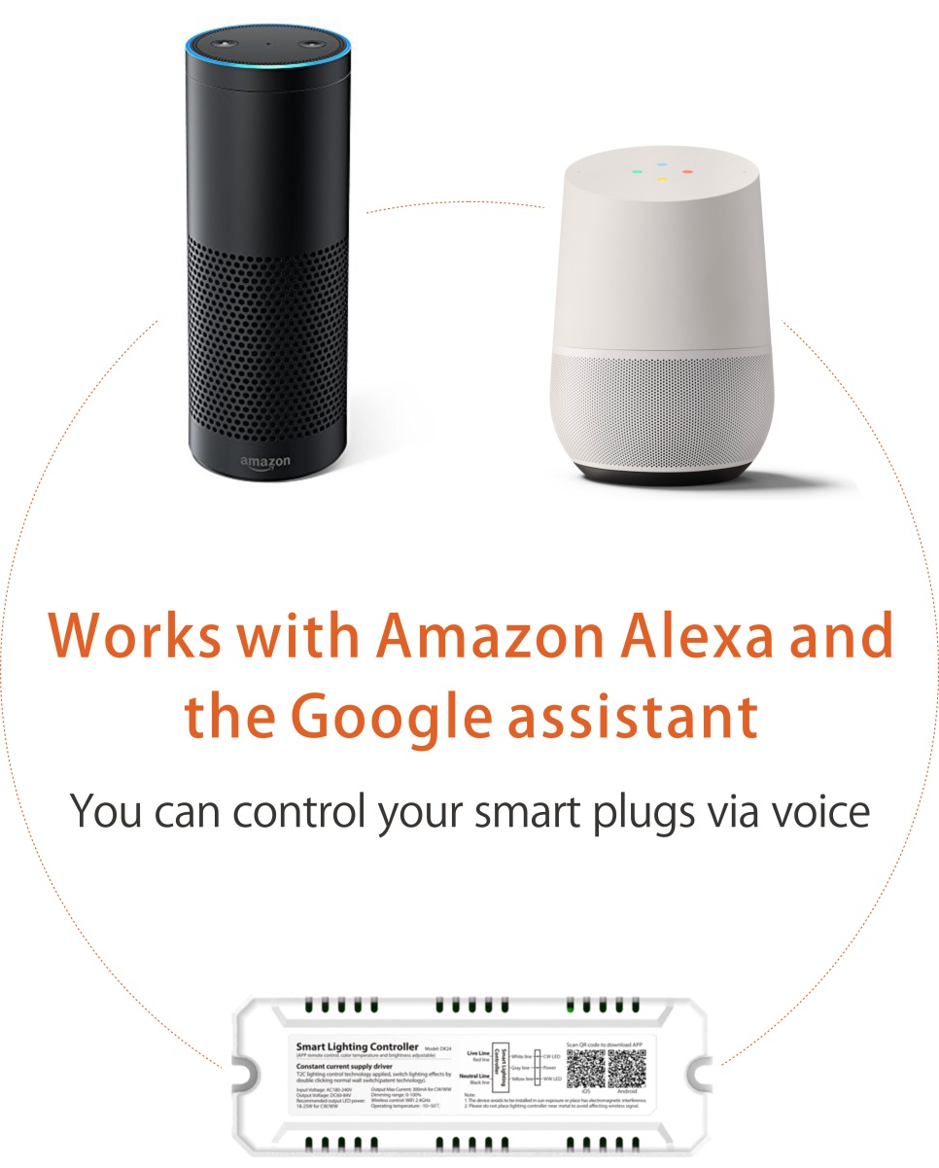

2.5 Technology Implement
The DK108 lighting controller assists traditional lighting manufacturer develop smart lighting lamps without stepping over technology gap, the lamps can be “T2C” controlled by overwhelming majority of SPST/SPDT. Users set their favorite lighting scenes via APP, then double click switch to change color temperature/brightness/lighting effect. It free users from mobile phones to make control more humane, intelligent.
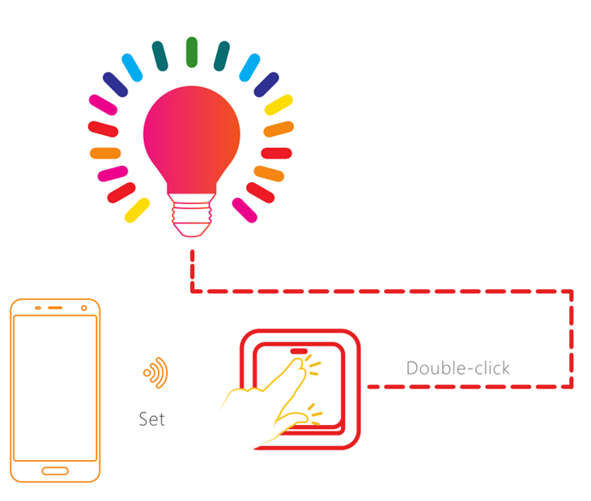
Figure2-2 T2C Technology Implement

Pin definition

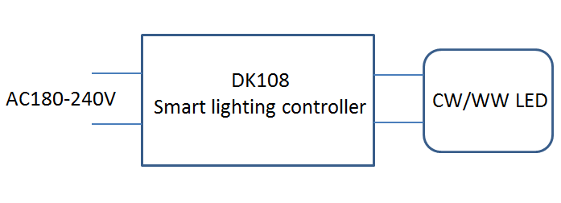
3.1 Block Diagram
Figure 3-1 Block Diagram

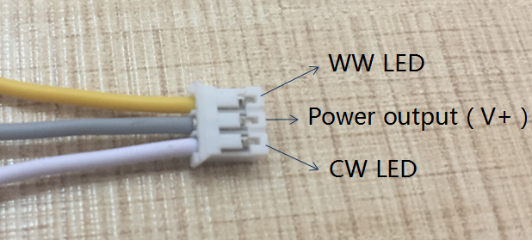
3.2 Pin Definition
Figure 3-2 Pin Description
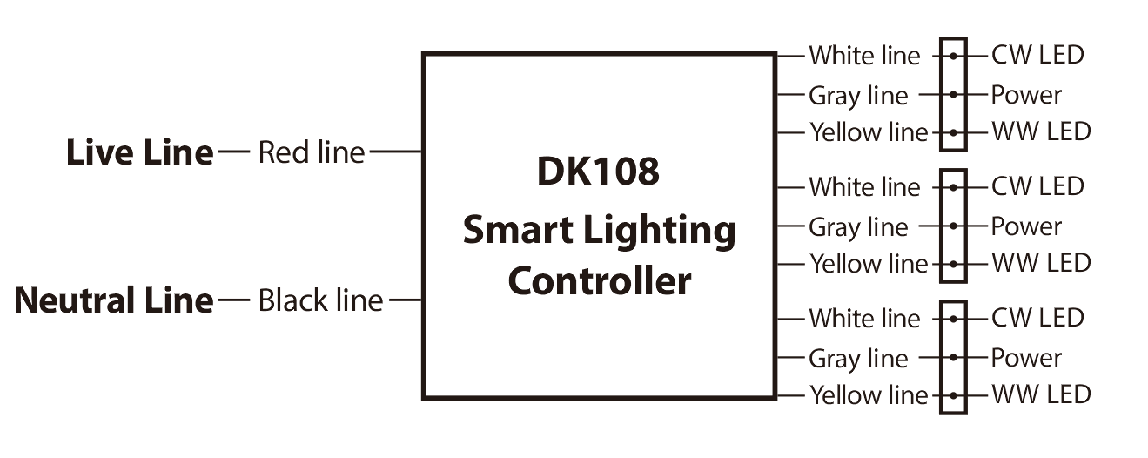 Figure 3-3 DK108 Pin figure
Table 3-1 DK108 Pin Definition
NO. |  | Description
1 | CW | Cool white LED, output 90-120V/300mA
2 | WW | Warm white LED, output 90-120V/300mA
3 | CW+WW | Output; 90-120V 300mA
4 | V+ | Output; DC90-120V 300mA
4 | Power input (L/N) | AC180-240V; AC input
Note:
1. Output Constant current: The max current for each way (CW/WW) is 900mA, the max current between DK108 lighting controller and LED PCBA is 900mA.
2. Output Voltage: DC90V-120V.
3. If the sequence of CW LED and WW LED line is opposite to our connector, you can reverse position of yellow line and white line of the connector.

Software Support

4.1 Software Support
In order to make traditional lamp manufacturer design and develop smart lighting lamps based on T2C lighting control technology, we provide developer with following details:
- iOS API and API application demo
- Android API and API application demo

4.2 APP Download
In DK108 evaluation, customers can test “Seetime Smart” APP to process configuration and evaluate function, now the “Seetime Smart” APP support Android 4.1 and iOS8.0 or above version, you can scan QR code below to install the APP, iOS/Android users can download “Seetime Smart” APP via App Store/Google Play.
APP Simplified Chinese name:” 智管家” , APP English name: ”Seetime Smart” .
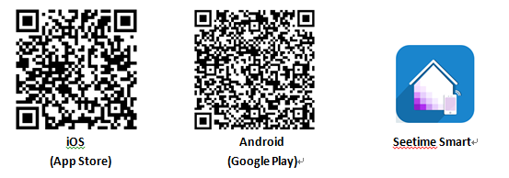

4.3 APP Function

4.3.1 Configuration
Step One, Set up DK108 and complete pin connection, power on LED and DK108, complete Seetime Smart APP installation.
Step Two: Connect mobile phone to 2.4G WiFi, open Seetime Smart APP, choose “T2C_CW” to enter networking interface, input current WiFi password and click “Next Step”.
Step Three: Open the lamp, You should reset the devices, Switch off→on→off→on the lamp to reset, which means that you need to keep pressing lighting switch 4 times quickly and continuously.( Note: The interval between each opening and closing can’t exceed 0.6 seconds, you must complete the whole device reset operation in 1.8 seconds, If the device reset is failed, please re-operate at a fast speed.)
Step Four: If the device reset is successful, the lighting will show quick flash. Then please confirm and click next step to start connection.
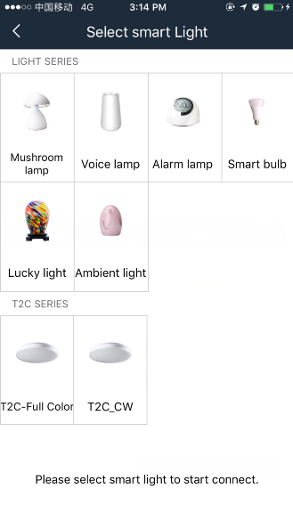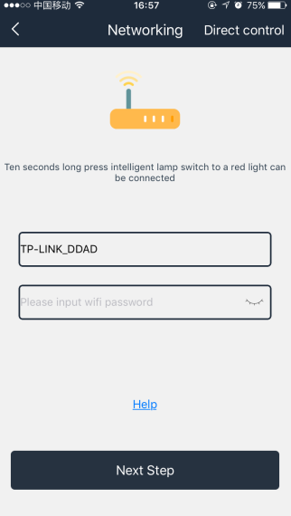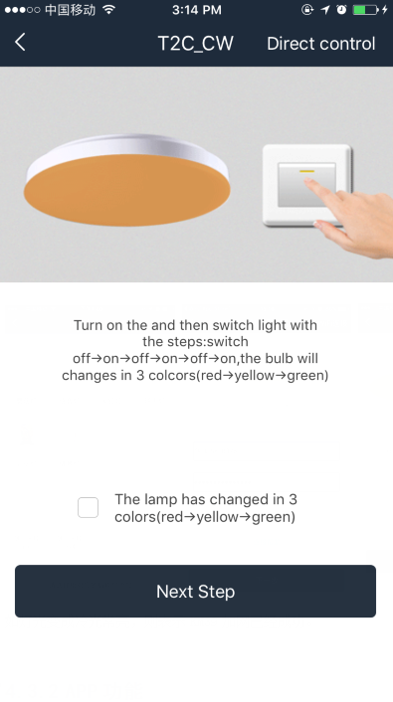
If the lamp changes to be keeping on, this means that the networking is successful.

4.3.2 APP Function
- Brightness control and color control, support 16 million colors.
- Group control, control several smart bulbs at the same time.
- T2C lighting control technology, double click normal switch to change scenes whenever you want.
- Flashing lighting effec supports
- Set timer and event reminder
- Game interactivity.
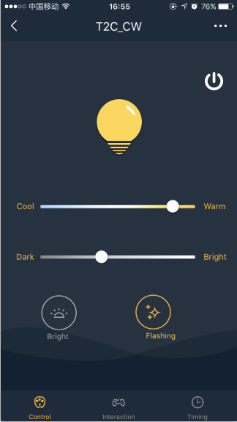

4.3.3 WiFi Work Mode
In general, After restoring factory settings and then connection is successful, DK108 mainly works in ”WiFi Control” work mode.
If there is no external WiFi, when restore factory settings, the lighting controller will automatically transfer to “Direct control” work mode after 60 seconds, the lamp will flash 3 times and then turn to be warm white, we could connect mobile phone to “Seetime Smart_XXXX”.
If the lighting controller works in ”WiFi control” mode, users select “Work Mode Setting” to switch work mode.
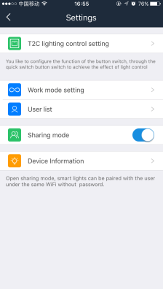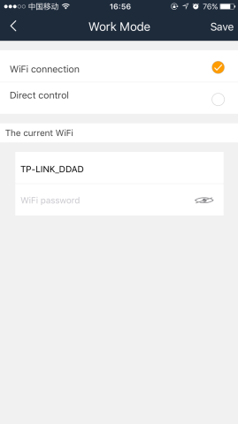

4.3.4 T2C Lighting Control Setting
We have four scenes in default for T2C lighting control.
Scene 1_Bright: Normally on; Pure White; 100% brightness
Scene 2_Comfort: Normally on; Pure White; 50% brightness
Scene 3_Fresh: Normally on; Cool White; 100% brightness
Scene 4_Warm: Normally on; Warm White; 100% brightness
Users set brightness/effect/color temperature they need to set scenes, then double click normal switch to change.
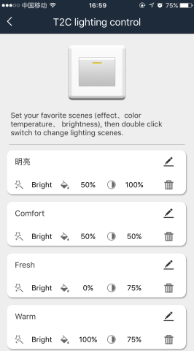

Integration

5.1 Set ”Alexa” APP
Remark: If you want to voice control your device with the Google assistant, the device must be added in STA work mode.
1. Once install the APP, the APP will ask you to register, select language and enter your email, input verification code and create a password. If you could not see the verification code well, you can click the code button to refresh and input again.
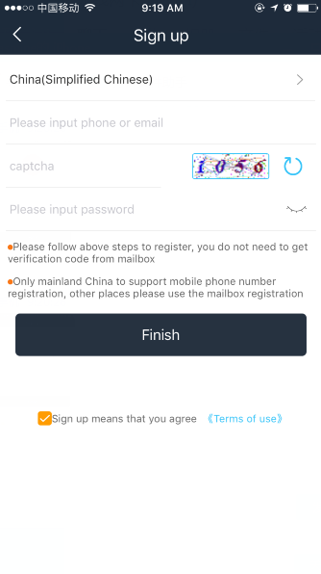
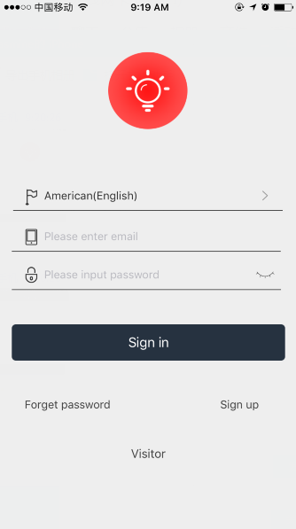
2. Once devices configured successfully, set a suitable name for your device, without unique names, you will be difficult to control the device via your voice with Alexa.
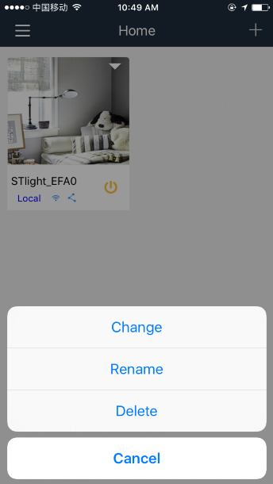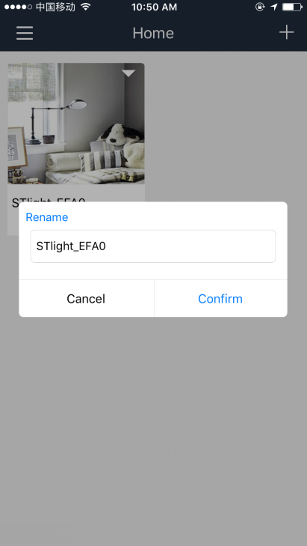
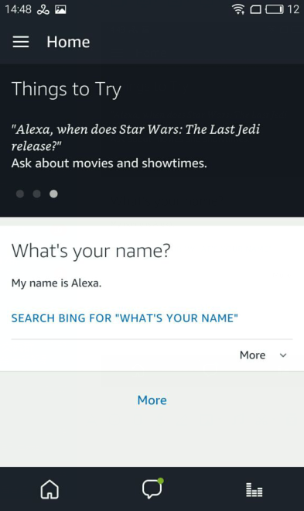
3. Open “Alexa” APP, Click . (As below highlighted)

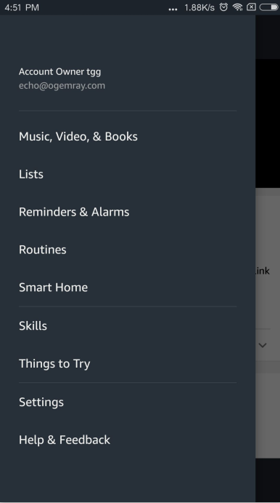
4. Click . (As below highlighted)
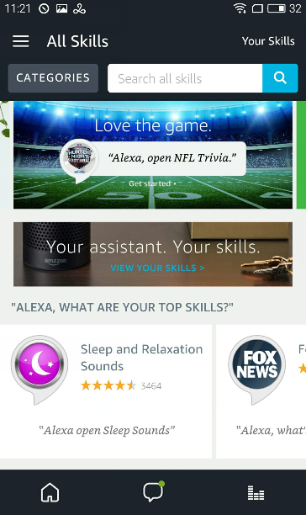
5. Input “seetime” to search skills, click search (See below highlighted)
6. Click “seetime” and enter.
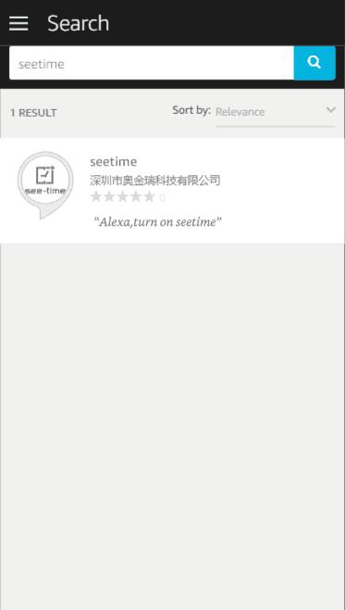
7. Click
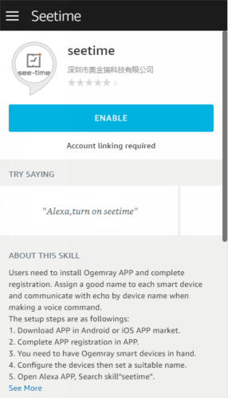
8. Input your “Seetime Smart” APP account and password which you have registered. (Attention: this is not the account and password of Alexa APP). Click
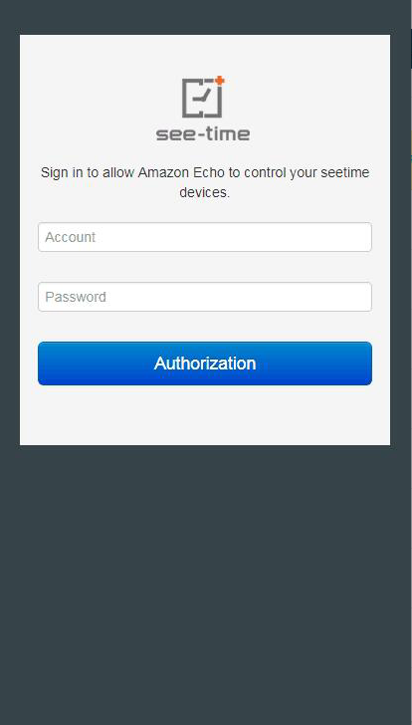
9. Close this window to discover smart devices you can control with Alexa
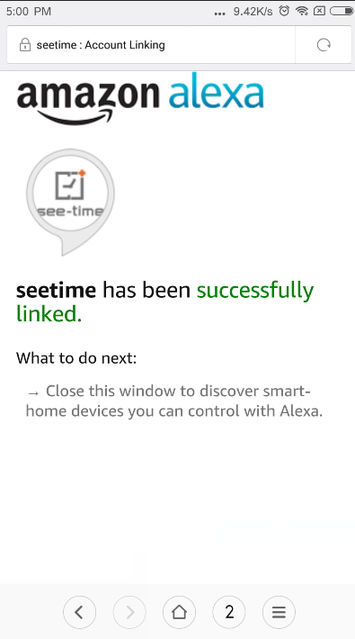
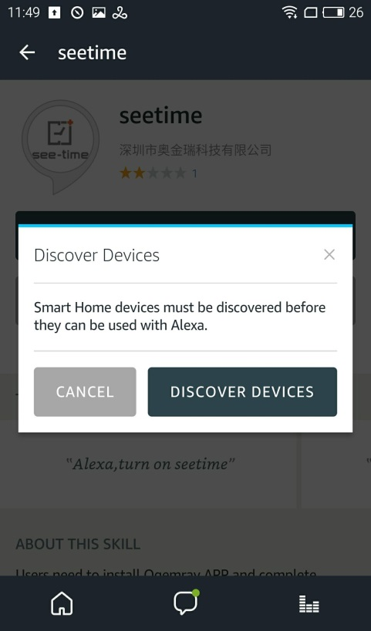
10. Click , then looking for devices.

11. Alexa is looking for devices
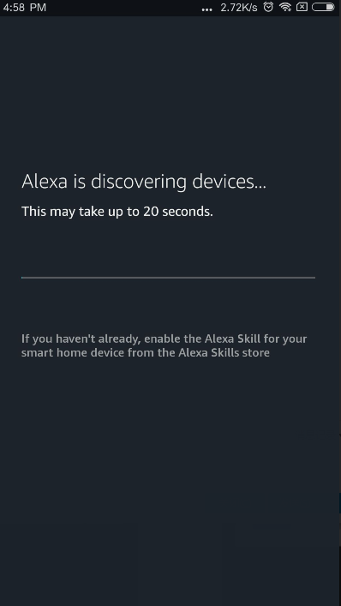
12. If successful, you will find the device list, then you can voice control the smart plug with Alexa
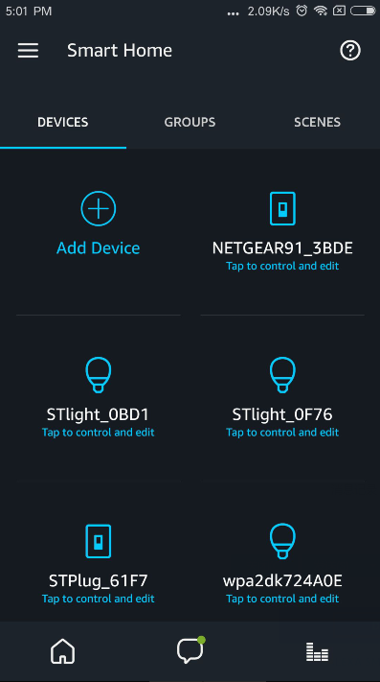

13. If failed, you will not find device list, please check FAQs to find out reasons, then discover devices again in the following interface. Click “Add Device”, Alexa will help you discover devices again.
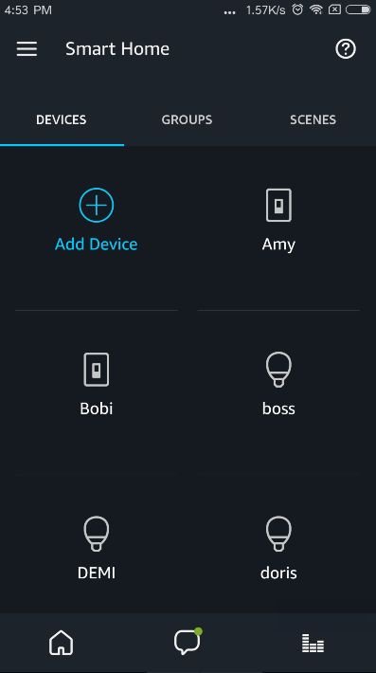
14. If users do not find the interface of discover above, they need to enter Smart Home interface, click “Smart Home”.
15. Click “Add Device”
16. After connection, try saying following commands to control the smart bulb.
Alexa, Turn on <device name>
Alexa, Turn off <device name>
Alexa, Set <device name> to daylight
Alexa, Set <device name> to warmwhite
Alexa, Set <device name> to 50%
Alexa, Decrease <device name> by 80%
Alexa, Increase <device name> by 80%
Alexa, discover my smart home devices

5.2 Set ”Home” APP
Remark: If you want to voice control your device with the Google assistant, the device must be added in STA work mode.
1. Open “Home” APP, click
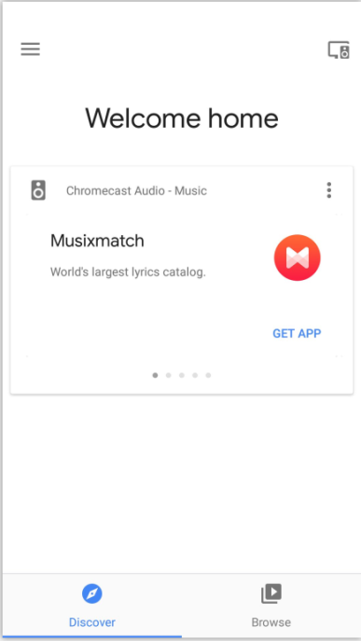
2. Click and enter
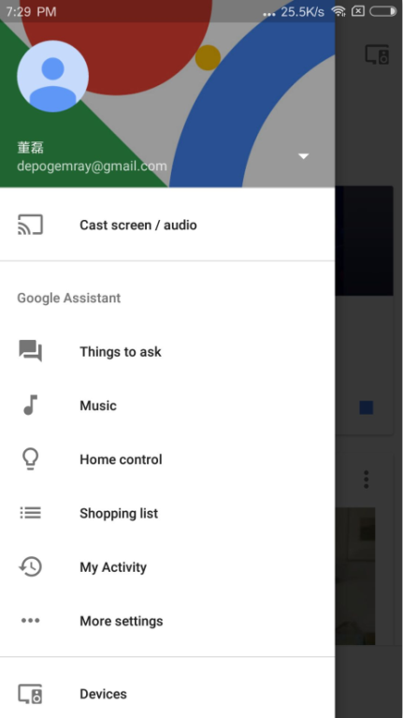
3. Scroll down the services list to find “seetime”, click 
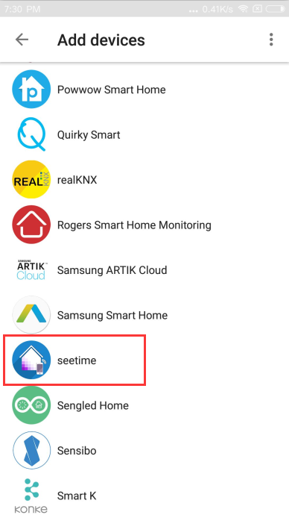
4. Input your “Seetime Smart” APP account and password which you have registered. (Attention: this is not the account and password of “Home” APP). Click
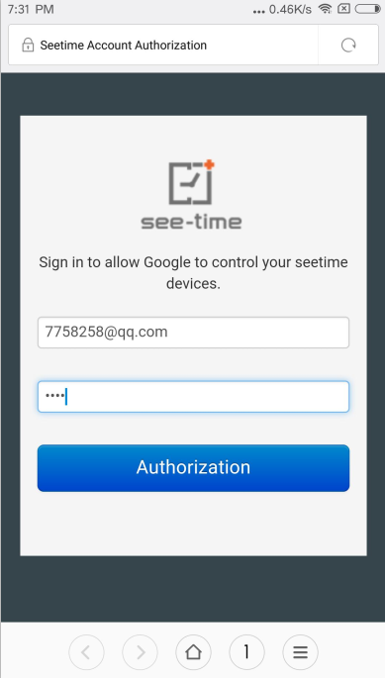
5. Click “OK” to open Google.
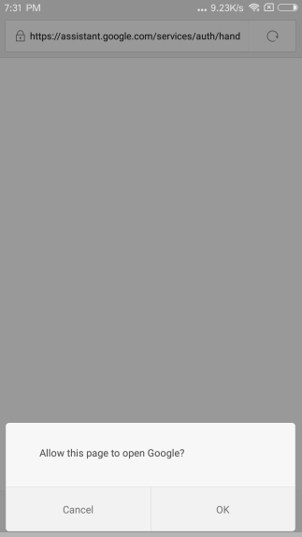
6. Google is linking your seetime account.
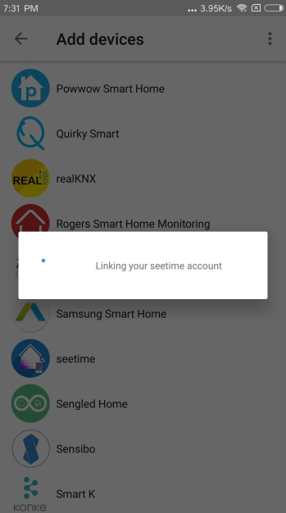
7. You can find the device list which has been configured by your “Seetime Smart” APP account. You can set a good name and assign room in “Home” APP. Click button you can find linked services.
Remark: Without unique name, you will be difficult to control the device via your voice, you can also voice control the devices by the name set in “see time Light” APP.
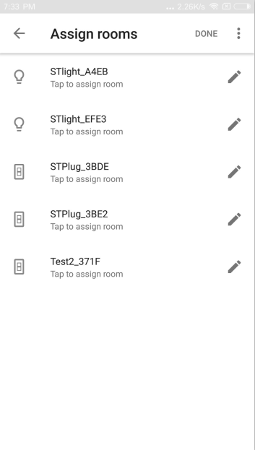
8. The following picture is linked services list.
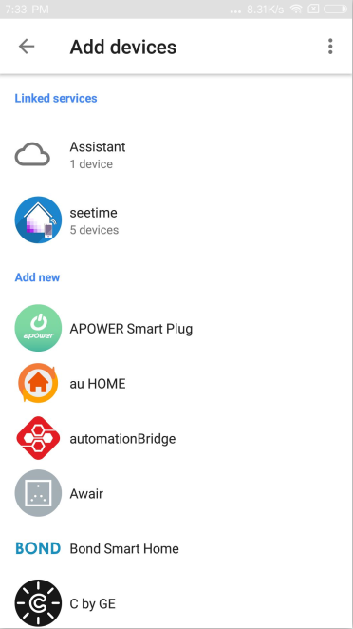
9. Then you can try saying following commands to control the bulb.
- Turn on/off
“Ok Google, turn on the <device name>”
“Ok Google, turn off the <device name>”
- Dim or brighten the light
“Ok Google, Brighten the <device name>”
“Ok Google, Dim the <device name>”
“Ok Google, Brighten the <device name> 20%”
“Ok Google, Dim the <device name> 20%”
- Verify that Google Home reports the correct status of the device.
“Ok Google, Is the <device name> on?”
“Ok Google, Is the <device name> off?”

Or you can try another queries as you want, like “Hi Google”, “Hey Google” or others.

10. After service linked, if you add new devices in “Seetime Smart” APP, you need to unlink “seetime” service then link the service again to refresh devices list, click “Home control”.
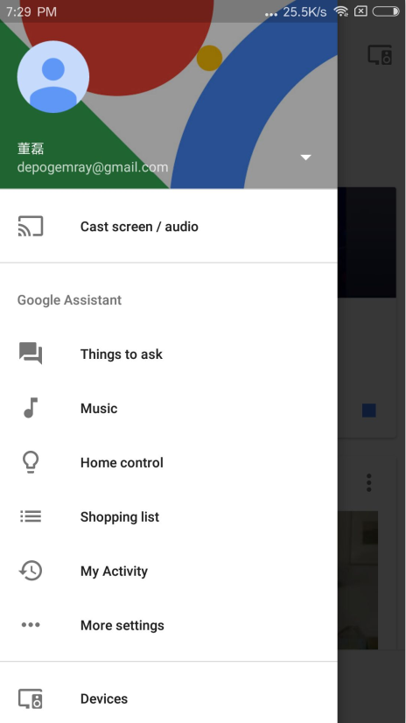
11. Click , enter linked services list.
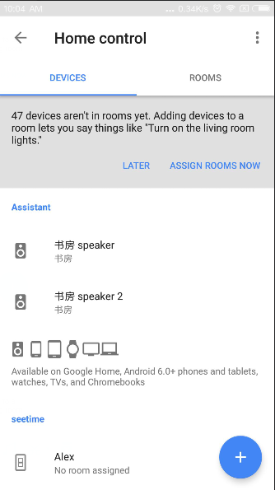
12. Click 
13. Click “UNLINK” to unlink seetime service and “Seetime Smart” APP account.
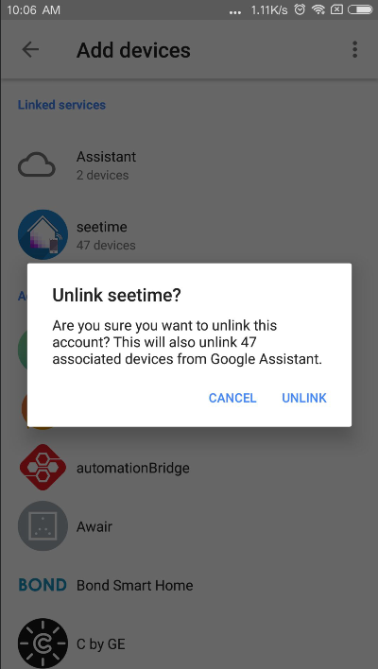
14. Please try to link “seetime” service and add devices again according to above steps 1-7 in this chapter. Then you can try saying commands in the step 9 of this chapter to voice control devices.

Product Specification
Table 5-1 DK108 Specification
Protocol and interface standard
WiFi Standard | IEEE 802.11b/g/n
WiFi Features
WiFi work mode | STA/AP/STA+AP/Smart Config
Security Specialty | None,WEP,WPA-PSK,WPA2-PSK (TKIP/AES)
WiFi RF Parameters
Frequency | 2.4GHz-2.5GHz (2400M-2483.5M)
RF Power | 802.11b (11Mbps): 18 +/-1.5dBm
RF Power | 802.11g (54Mbps): 15 +/-1.5dBm
RF Power | 802.11n (72.2Mbps): 14 +/-1.5dBm
Application
Applicable lamp | 81~108W lamps such as ceiling lamp, down lamp or other
Lighting controller solutions
Power supply solution | Constant current and isolated power solution
Dimming mode | Digital PWM dimming
Power Input
AC Power Input | AC180V-240V
Standby Current | 5mA
Output
Output Voltage | DC90-120V
Output Current | 900mA for CW/WW(There are three outputs for CW and WW)
Recommended LED power accessed | 81-108W for CW/WW
Lamp Dimming Range | 0%~100%
Antenna
Antenna mode | External antenna
Work environment
Work temperature | -10ºC to +50ºC
Storage temperature | Normal temperature
Work humidity | 5% to 60% (No condensing)
Physical Parameters
Dimensions | 268.00*51.40*29.60mm
RF Range
Indoor: 40m, Outdoor: 80m (varies with the environment)
Package
DK108 smart lighting controller;
User manual
Packaging box

Approval and Certification
Table 6-1 Approval and Certification
Certification | Approval
CE | Ongoing
FCC | Ongoing
RoHS | Pass

Disclaimer
These material and information are provided “as is” without warranty of any kind, either express of implied, including but not limited to, the implied warranties of merchantability, fitness for a particular purpose or non-infringement.
We use reasonable efforts to include accurate and up-to-date information on this document, it does not, however, make any representations as to its accuracy or completeness of the information, text, graphics, links or other items contained within these materials. Your use of this Document is at your own risk. Ogemray, its suppliers, and other parties involved in creating and delivering this Document’s contents shall not be liable for any special, indirect, incidental, or consequential damages, including without limitation, lost revenues or lost profits.

